VACATION BIBLE SCHOOL KITS
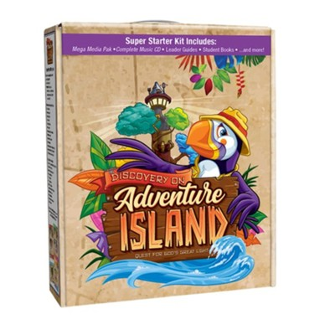

Discovery on Adventure Island Super Starter Kit Plus Digital:
Quest for God's Great Light – (3 kits added Spring 2021)

Cokesbury's exciting 2021 VBS program invites everyone to explore the ways God's great light shines in the world, and shows them how they can reflect that light in their own lives. From a whimsical lighthouse on an enchanted island, Explorers are guided by a Lighthouse Keeper and Beacon the Puffin on an exciting quest to find five mysterious Infinity Lanterns to help light their way. Using map coordinates from their Reference Book (the Bible), children discover clues to finding each Lantern while learning how God's light shines in the lives of familiar biblical characters in Old and New Testament stories. Participants will:

- Learn about God's creation and strive to care for it
- Be encouraged to trust God even when fearful Understand how to act on their faith Celebrate God's work in their lives Be reminded to share God's hope The Super Starter Kit includes:
- Director Guide
- Leader Guides for Bible Storyteller, Preschool/Kindergarten, Craft, Music, Science, Assembly, Recreation, Decorating, and Reflection Time
- Sample copy of age-level student books for Preschool/Kindergarten, Younger Elementary, and Older Elementary
- Complete Music CD
- Samples of publicity and craft materials
- Mega Media Pak
- Access to FREE online registration for your church (CokesburyVBS.com)
- Offer for free download of Mission and Snack Leaders

Also includes the following Digital components:
- Digital Versions of Director Guide and these leader guides: Bible Storyteller, Preschool/Kindergarten, Craft, Music, Science, Assembly, Recreation, Decorating, Reflection Time
- Audio Files of each song on the Complete Music CD
- All files from the Mega Media Pak including MP4 files of the music and adventure videos
- Downloadable Lyric Sheets with Guitar Chords

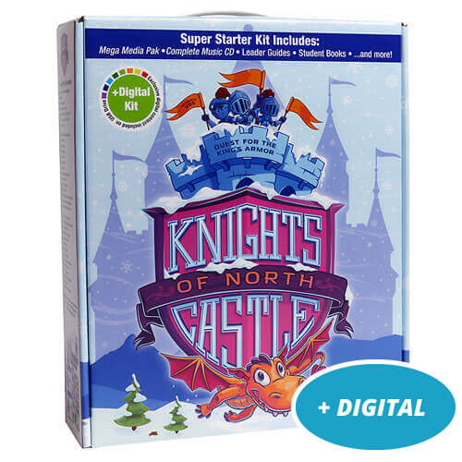

KNIGHTS OF NORTH CASTLE VBS (3 KITS – ADDED FALL 2020)

North Castle is hidden in a frozen land. The King’s valiant Knights are on a quest in search of the King’s Armor. But the armor isn’t what they think it is.

Cokesbury’s VBS 2020, Knights of North Castle: Quest for the King’s Armor, invites children to be strong in the Lord and in the strength of his power by exploring how we put on the armor of God. Kids will take on the role of brave Knights and begin their quest each session by opening the King’s Book.

They’ll explore Old and New Testament stories and discover different pieces of protective armor — the Belt of Truth, the Breastplate of Justice, the Shoes of Peace, the Shield of Faith, and the Helmet of Salvation — at work in the lives of familiar Bible characters, and explore how that armor works in their own lives as they follow and serve God.
Help kids take up the gauntlet this summer and accept the challenge to “armor up” and be strong by remaining with God.

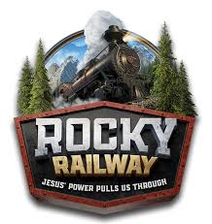

ROCKY MOUNTAIN RAILWAY VBS (3 KITS – ADDED FALL 2020)
During each day’s Bible lesson, your tiny conductors will learn a new element of God’s power. On Day 1, Scale the mountain with Ramsey the ram, and learn that God’s power can help us do hard things! Team up with Ava the Hawk to see how Paul encouraged others in a storm. Jesus’ power gives hope! On Day 3, Jesus helps you and Sierra the Lioness be bold, just like Peter and John were! Swim around with Finn the Rainbow Trout on Day 4! Finn will show you how Jesus’ Power lets us live forever. Your journey comes to an end with Lawrence Elk, a friendly guy who will help us see that Jesus’ power helps us be good friends.
All Aboard! Start each day at Sing & Play Express before heading on an awesome roundabout of stations, including Loco Motion Games, Bible Adventures, Imagination Station and Chew Chew Snacks! Then, head to the caboose for Rocky Wrap-Up.
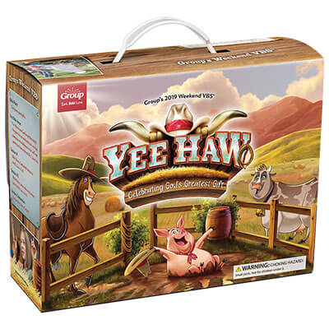

YEE HAW WEEKEND VBS KIT (2 KITS – ADDED FALL 2019)

Saddle up for a trailblazing weekend of fun! Kids'll kick up their heels at Yee-Haw VBS as they stampede through the wild frontier and celebrate the greatest truth of all - God is good!

Starter Kit Includes

- The Director Manual contains everything you need to plan a successful program, recruit and train volunteers, publicize your program, and follow up with families after the big event.
- Leader Manuals - The Leader Manual provide easy instructions for specific roles at your Yee-Haw VBS. Each manual includes an overview of each day’s Bible content, historical backgrounds, step-by-step directions for each activity, and guided discussion questions.
- Helpful DVD and CDs feature training resources that make it easy to inspire and educate your church body.
- Student Resources, including the Bible Memory Buddy, will keep kids talking about Yee-Haw throughout their
VBS experience and long after they leave your church event.

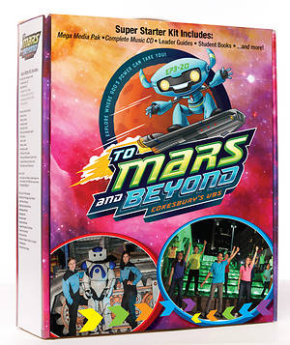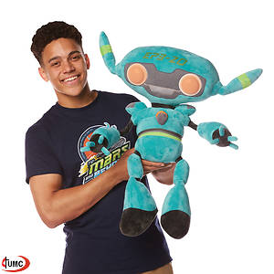

TO MARS AND BEYOND – (ADDED 2019 - 3 KITS
and EP3-20 LIGHTED ROBOT PUPPET

One small step for your kids...one giant leap for God's Kingdom!

Blast off with the first VBS to land on Mars! Cokesbury's To Mars and Beyond will help kids discover the wonders of God's universe. They'll become Voyagers on a journey through space, exploring where God's power can take them. Beginning in your Assembly area-an outpost on Mars-they'll lift off to distant planets on special missions to collect power sources. Along the way, they'll learn how God walked with heroes of the Bible, and that God is always with them, too. Add to the adventure with out-of-this-world fun, learning, and timeless Bible stories that inspire kids to give glory to God, who is able to do far beyond all that we could ask or imagine!

The To Mars and Beyond Super Starter Kit has everything you need to help your kids explore where God's power can take them!

The theme verse (Vector Verse) is "Glory to God, who is able to do far beyond all that we could ask or imagine by his power at work within us." —Ephesians 3:20, CEB – From Cokesbury Publishing

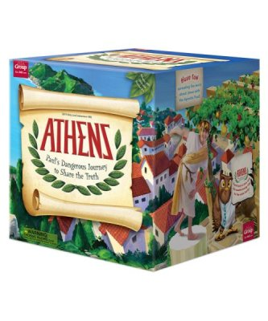
ATHENS – THE STORY OF THE A POSTLE PAUL – (ADDED FALL 2018 - 2 KITS)

Learn the jaw-dropping story of the Apostle Paul straight from Paul himself! In an ancient "anything goes" culture, Paul will inspire kids to share the truth of God's immeasurable love today! The Athens Starter Kit is packed with everything you need to get your Holy Land Adventure VBS started! – from Group Publishing
The Athens VBS Ultimate Starter Kit includes:
- Athens Ultimate Director Go-To Guide®: The ultimate step-by-step resource for planning, recruiting, promoting, training and everything a successful director needs.
- Leader Manuals: Completely field-tested and easy-to-use, these station leader guides empower your volunteers to easily deliver the best VBS experience ever!
- Marketplace Sampler: With this crafty collection of fun projects, kids step back and time to discover what life was like in a Athensian bazaar.
- Oikos Time Teaching Kit Sampler: Tribe Time is a key part of Athens, filled with eye-catching, jaw-dropping, big-on-Bible object lessons for small groups.
- Student Resources Sampler: This sampler gives you a sneak peek at the Banduras, Bible Memory Makers, name badges, and other resources for your Athens adventure.
- Music: Your kit includes the Leader Version of all 10 high-energy Athens songs, including the instrumental-only tracks and song lyrics slide show.
- Clip-Art: An awesome collection of graphic resources, bulletin inserts and more!
- Media: Your starter kit comes with the Decorating Places DVD, Ultimate Director Go-To Recruiting and Training DVD, and the complete music video DVD.
- Missions and More: Your ultimate starter kit also includes a missions project sampler plus information on lots of other awesome VBS resources.

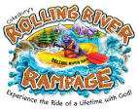

ROLLING RIVER RAMPAGE – ADDED 2018 - 3 KITS)

The Rolling River Rampage Super Starter Kit has everything you need to help your kids experience the ride of a lifetime with God!

The Rolling River Rampage Super Starter Kit provides everything you need to kick-start your VBS! The theme Bible verse is "When you pass through the waters, I will be with you." —Isaiah 43:2, CEB

Sessions include:
Session 1 - Jesus Calls the Disciples (Matthew 4:18-25)
Session 2 - Jesus Accepts Mary and Martha (Luke 10:38-42)
Session 3 - Jesus Walks with Zacchaeus (Luke 19:1-10)
Session 4 - Jesus Shares a Special Meal (Luke 22:14-20)
Session 5 - Jesus Makes a Promise (Matthew 28:16-20)

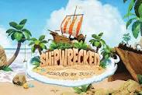

SHIPWRECKED – (ADDED 2018 – 3 KITS)

Get ready for an adventure to an uncharted island where kids are Rescued by Jesus! Your Shipwrecked Ultimate Starter Kit is packed with everything you need to get started on a 5-day VBS experience where kids are anchored in the truth that Jesus carries them through life's storms.

The Ultimate Director Go-To Guide and Leader Manuals in this 2018 Group VBS provide step-by-step instructions. Plus, you’ll get student resource samples, volunteer resources, a Shipwrecked VBS catalog packed with program products, and essential media tools.

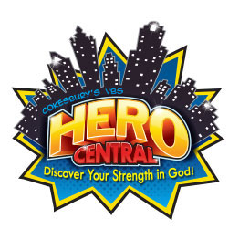
HERO CENTRAL (ADDED 2017-2 KITS)

Hero Central VBS has everything you need to help your kids discover their strength in God and realize that they are God's heroes! The theme Bible verse is "Do good! Seek peace and go after it!" —Psalm 34:14b, CEB

Sessions include:
Session 1 - Samuel Anoints David (1 Samuel 16:1-12)
Session 2 - Abigail Saves the Day (1 Samuel 25)
Session 3 - Jesus Goes to the Temple (Luke 2:41-52)
Session 4 - Beatitudes (Matthew 4:23-5:12)
Session 5 - Pentecost (Acts 2:1-41)

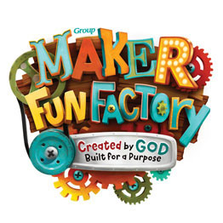

MAKER FUN FACTORY (ADDED 2017-2 KITS)

Maker Fun Factory is the all-in-one program designed to make your church’s VBS program simple for your leaders and unforgettable for your kids. Bible points include: God made you, God is for you, God is always with you, God will always love you, and God made you for a reason. Bible stories include: God lovingly made you, Rahab believes in God’s might power, God is with Gideon, Jesus dies and comes back to life, and Abigail brings peace.

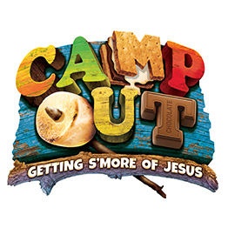
CAMP OUT (Weekend VBS – ADDED 2018 - 3 KITS)
Grab your gear for the ultimate weekend getaway. At Camp Out VBS, kids trek through an outdoor adventure―minus bug spray and lack of sleep! Kindle friendships and help kids discover that Jesus is the light of the world. Key Bible Verse-“Jesus said, I am the light of the world.” (John 8:12)

YOUR STARTER KIT INCLUDES

- Director Guide contains everything you need to plan a successful program, recruit and train volunteers, publicize your program, and follow up with families after the big event.
- Leader Manuals provide easy instructions for specific roles at your Camp Out VBS. Each manual includes an overview of each day’s Bible content, historical backgrounds, step-by-step directions for each activity, and guided discussion questions.
- Helpful Music & Media Tools feature program resources for your VBS, and the Camp Out Music CD will have your kids in celebration mode.
- Student Resources, including Bible Memory Buddy and student resource samples, will keep kids talking about Camp Out throughout their VBS experience and long after they leave your church event.

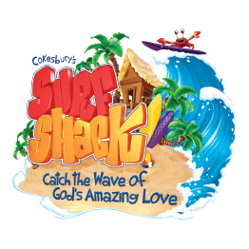
SURF SHACK- (ADDED 2016 - 4 KITS)

The Surf Shack Super Starter Kit provides everything you need to start surfin' the waves of VBS! The theme Bible verse is "Remember that the Lord is great and awesome." —Nehemiah 4:14b, CEB

Session 1 - Creation (Genesis 1)
Session 2 - Miriam Cares for Moses on the Nile (Exodus 2:1-10)
Session 3 - Baptism of Jesus (Matthew 3:13-17, John 1:29-34)
Session 4 - Jesus Calms the Storm (Luke 8:22-25)
Session 5 - Breakfast on the Beach (John 21:1-17)

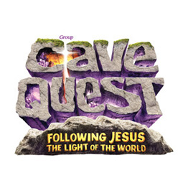
CAVE QUEST- (ADDED 2016 - 3 KITS)

Cave Quest VBS Ultimate Starter Kit starts you on an amazing adventure! Go spelunking through dark caves with Jesus as your light. Kids learn Jesus is the solid foundation of God's love, who lights our way and gives us Hope, Courage, Direction, Love and Power for each new day. Cave Quest Easy VBS encourages kids to follow Jesus where ever he will lead them!

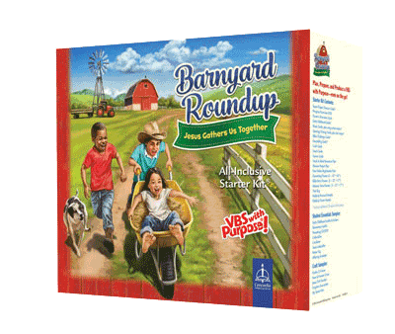

BARNYARD ROUNDUP- (ADDED 2016 - 2 KITS)

Jump into a VBS that’s all about Jesus! At Barnyard Roundup, kids discover that Jesus knows their name, rounds them up, and brings them home. He is with us always and forever—no matter what! Explore the beloved passages of Psalm 23 and discover how He cares, provides, and leads us now and forever. Our Barn Raising Storytelling and Science in the Sheep pen are sure to deliver a blue ribbon VBS in your community.

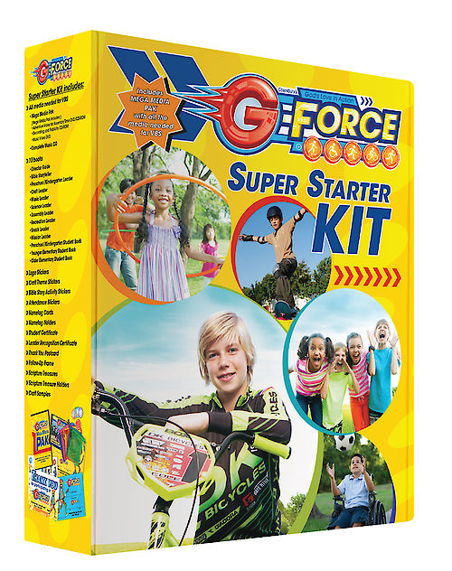

G-FORCE- (ADDED 2015 - 2 KITS)

At Cokesbury’s G-Force VBS, kids explore how to put their faith into action. In this mission-focused VBS, kids experience God’s unstoppable love and discover how to fuel up and move in and through life with God. Watch your church come alive with movement and images of all sorts of kid-friendly transportation, such as skateboards, running shoes, roller blades, and more! Watch the G-Force meter climb illustrating how God is at work around the world and how God’s people are on the move. The overall Bible verse for the program is Acts 17:28a, "In God we live, move, and exist." A life with God is one of movement! Each session’s action word sparks a way to show God’s unstoppable love: Move! Act! Care! Follow! Share! Go out and serve!

Session 1 - God Calls Moses (Exodus 3:7-12)
Session 2 - Solomon Builds the Temple
(1 Chronicles 28:20-21 & 2 Chronicles 5:1, 13)
Session 3 - Four Friends Help (Mark 2:1-12)
Session 4 - Healing of Bartimaeus (Mark 10:46-52)
Session 5 - Women Find the Empty Tomb (Luke 24:1-12)

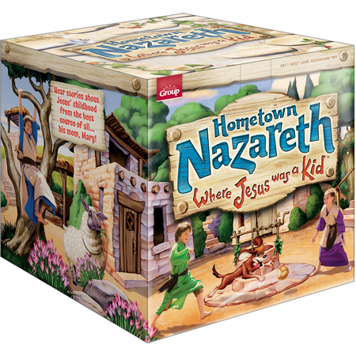

HOMETOWN NAZARETH- (ADDED 2015 - 1 KIT)

Hometown Nazareth: Where Jesus was a Kid, the Holy Land Adventure 2015 VBS from Group Publishing. Take kids back to Jesus' hometown of Nazareth, where they'll stand up for their faith among people who doubt that the carpenter's son is really God's son. Totally immerse children in ancient Bible times where they will hear stories about Jesus' childhood from the best source of all-his mother! They learn to relate to Jesus since he had a family (Luke 1), a name (Luke 2), a home (Matthew 2), and he went to church (Luke 2:41-52) and served others (John 2).

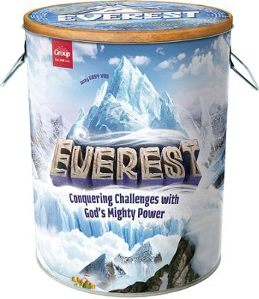

EVEREST- (ADDED 2015 - 3 KITS)

Everest: Conquering Challenges with God's Mighty Power! - the 2015 Easy VBS from Group. Embark upon an icy expedition where your kids learn to overcome obstacles with God's awesome power! Transform your church to majestic mountains with breathtaking views as experienced sherpas guide children to new summits in trusting God. Each day kids climb the path and learn God has the power to provide (Elijah), comfort (Elijah), heal (Naaman), forgive (the cross), and love us forever ("I go to prepare a place for you." John 14).

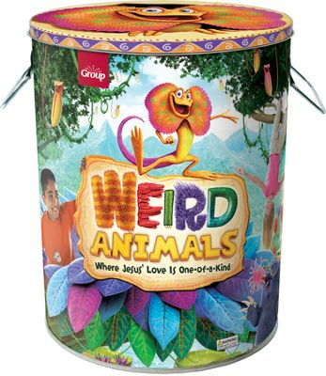

WEIRD ANIMALS- (ADDED 2014 - 3 KITS)
Weird Animals VBS connects with children when they feel different by introducing them to wonderful animals around the world. When "weird" means special, unique, and one-of-a-kind, kids are reminded of Jesus' special love for them - even when they feel different! Jesus loves you even when...you're left out, you're different, you don't understand, you do wrong, and when you're afraid.
Weird Animals Bible Points (and Bible Story):
Day 1: Even when you're left out...Jesus loves you! (Jesus heals the lepers: Luke 17:11-19)
Day 2: Even though you're different...Jesus loves you!(Jesus reaches out to a Samaritan Woman: John 4:1-30)
Day 3: Even when you don't understand...Jesus loves you! (Jesus washes the disciples' feet: John 13:1-17)
Day 4: Even though you do wrong...Jesus loves you! (Jesus dies and comes back to life: Luke 22:47-24:12)
Day 5: Even when you're afraid...Jesus loves you! (Ananias bravely helps Saul: Acts 9:1-19)
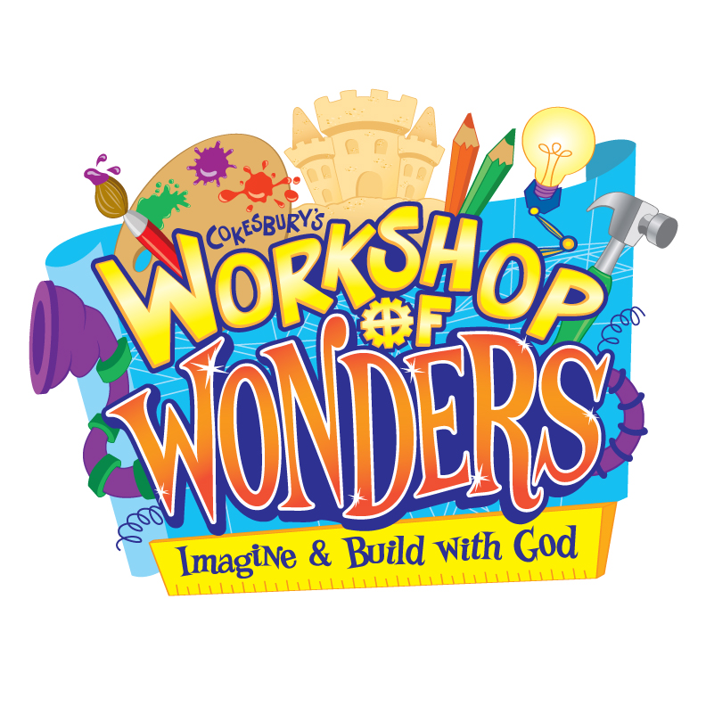

WORKSHOP OF WONDERS- (ADDED 2014 - 1 KIT)

At the Workshop of Wonders (WOW) VBS, discover how the ordinary becomes extraordinary with God! Experience the love of Jesus. Start an adventure. Use your imagination and creativity to build your faith. Meet people from the Bible who used what they had to produce something amazing with God. Use your heart, mind, and imagination to participate in the creative life of God, the one who works wonders!

Session 1 - Imagine with God!
The Story of Esther (Book of Esther)
Session 2 - Build with God!
Rebuilding the Lord's House (Ezra, 3:8-13)
Session 3 - Grow with God!
Parable of the Mustard Seed (Matthew 13:1-2, 31-32)
Session 4 - Work with God!
Feeding the 5,000 (John 6:1-13)
Session 5 - Walk with God!
Walking to Emmaus (Luke 24:13-32)

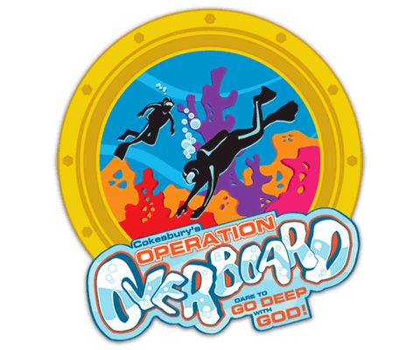

OPERATION OVERBOARD- (ADDED 2012 - 2 KITS)

Dive in and discover God’s underwater universe! Swim with humpback whales and seahorses, scuba through a vibrant coral reef, and take a personal submarine to the ocean floor, where eels and octopi play. As they journey miles below the water’s surface, kids plunge into Bible stories of people with deep faith and learn to trust a God whose love is bigger than the sea. Participants will learn to “go deep” into God’s Word for their lives, exploring the meaning and application of Bible stories about people who exhibited deep faith. Bible Stories Theme Scripture for the Week: “Faith is the reality of what we hope for and proof of what we don’t see.” (Hebrews 11:1, CEB)

Session #1 Noah Depends on God (Genesis 6:9-13, 6:22-7:17, 8:1, 8:13-9:17)
Session #2 A Servant Girl Dares to Care (II Kings 5)
Session #3 John Proclaims Jesus (Matthew 3:1-17, Mark 1:1-11, Luke 3:1-22)
Session #4 The Disciples Choose to Follow Jesus (Luke 5:1-11, John 21:4-24)
Water Connection- The disciples fished in a boat on the Sea of Galilee.
Session#5 Paul Delivers Good News- (Acts 27)

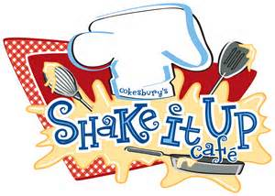

SHAKE IT UP CAFÉ- (ADDED 2011 - 1 KIT)

Jesus called us to "shake up" our lives and become his followers. The Bible gives us the recipe: be ready for God's call, give happily to God and others, believe fully in Jesus as God's son, remember Jesus' life and teachings, and celebrate God forever. Shake It Up Café introduces your children to stories of biblical festivals that reveal these ingredients and link the Old Testament, the New Testament, and our lives today. The stories included are: Israelites Celebrate Passover, Festival Celebrations for the Israelites, Jesus Celebrates the Festival of Booths, Jesus Celebrates Passover, and Celebrating the Festival of Weeks and Pentecost.

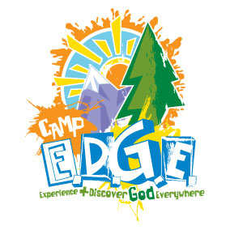
CAMP E.D.G.E. – (ADDED 2009 - 2 KITS)
Your campers begin to experience and discover God everywhere when they learn an E.D.G.E. pledge, a statement of faith followed by an active response of faith. God is with me. I will stay close to God. God guides me. I will follow.

God teaches me. I will learn. God loves me. I will love God and others.
God sends me. I will go. You will take a trek to the Promised Land, Bethlehem, The Pharisee's House, The Upper Room, and to Galilee

