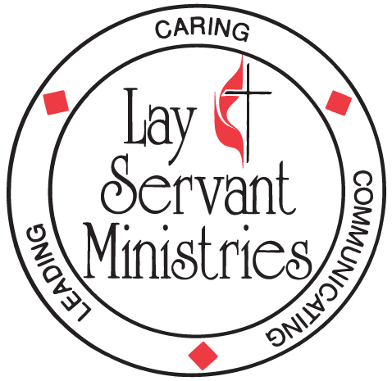

APPLICATION FORM
Please Print Legibly

By your signature you indicate this candidate has met the necessary expectations and requirements to enroll in the Certified lay Ministry Course of Study.

Applicant Name: |  | Date:
Address:
City: | State: | Zip Code:
Phone (Day):
Phone (Evening or Cell):
Email address:
I am a Certified Lay Servant | Certification date
Title/Position(s) in the UMC:
District:
Home Church:
Address:
City: | Sate: | Zip:
Applicants Signature: |  | Date:
Pastor’s Name: |  | Phone:
Pastor’s Signature: |  | Date:
Council Chair Name: |  | Phone:
Council Chair Signature |  | Date:
SPRC Chair Name: |  | Phone:
SPRC Chair Signature |  | Date:

Original application with signatures must be sent to District Committee on Ordained Ministry

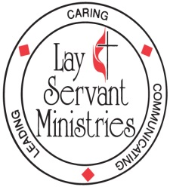

Certified Lay Ministry Process – Adopted Legislation at 2016 General Conference
(For more details please see Certified Lay Ministry Applicants Packet)

As part of a ministry team with supervision and support of a clergyperson:

- Conducts public worship
- Cares for the congregation
- Develops new faith communities
- Preaches the Word
- Leads small groups
- Establishes outreach ministries
- Serves as a class leader
- Engages in specialized ministries after appropriate training

REQUIREMENTS FOR CERTIFICATION:

- Certified as a lay servant, lay missioner
- Pastor and church council or charge conference recommendation
- Completion of a track of study as defined in ¶268 2016 Book of Discipline
- District Superintendent recommendation
- Appropriate screening & assessment
- Conference committee on Lay Servant Ministries approval after interview with and recommendation from district committee on Ordained Ministry

REQUIREMENTS FOR RENEWAL:

- Annual report
- Pastor and church council or charge conference recommendation
- Ministry review
- Lay Servant Ministries advanced course or approved continuing education event annually
- District Superintendent recommendation
- Conference committee on Lay Servant Ministries approval every two years after interview with and recommendation from district committee on Ordained Ministry

