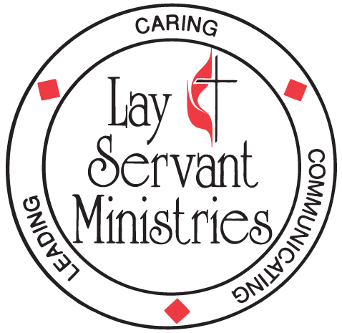
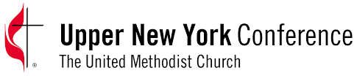

Certified Lay Ministry
Information and Guidelines Checklist

These guidelines are for you to use and follow to ensure you have completed all the required and recommended steps and that you understand all the requirements for you to enroll in the Certified Lay Ministry program (CLM).

Procedures and Processes
I have met with my pastor to discuss my sense of calling to this ministry.
I have read The Christian as Minister, published by The UMC Board of Higher Education and Ministry, ISBN 13-9780938162636
I have had all the required meetings:
- Meeting with my Pastor
- Meeting with my SPRC
- Meeting with my District Superintendent at the request of my pastor
I am a Certified Lay Servant
I have an appreciation and understanding of the United Methodist history, polity, doctrine, worship and liturgy of the United Methodist Church through service in the local church.
I have submitted my completed CLM required documentation and sent everything to the District Committee on Ordained Ministry:
- Applicant Application with ALL signatures
- Biographical Information Form
- Pastor’s Recommendation (can be sent separate by the pastor)
I will participate in, and pay the required fee, for a background screening for criminal records search, sex offenders search, credit report search and driver’s license report when requested to do so.
I will commit to the training, learning and discernment in the CLM process:
- Complete Modules 1-4 at a location that works for me or online through BeADisciple.com
- I understand I am responsible for any fees associated with taking the course Modules.
I will enter into this joint partnership with a pastor as a ministry partner as described in ¶268 of the 2016 Book of Discipline of the United Methodist Church
I will commit to regular meetings and working sessions with the pastor assigned to me.

Understandings around Certified lay Ministry
I understand the primary intent of a CLM is to serve as a congregational leader, a ministry team leader and to work alongside the clergy as part of a ministry team.
I understand that completion of the Certified Lay Ministry course of study does not lead to an appointment in The United Methodist Church.
I understand that I could be asked and assigned by my District Superintendent to provide lay leadership in a ministry or in a church with pastoral responsibilities.
I understand that a CLM has no clergy rights or benefits, which means as a CLM I cannot consecrate the elements of Holy Communion or officiate the Sacrament of Baptism

I, understand and commit to the procedures, process and understandings.

Signature Date

(Keep this for your records)

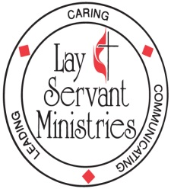

Certified Lay Ministry Process – Adopted Legislation at 2016 General Conference
(For more details please see Certified Lay Ministry Applicants Packet)

As part of a ministry team with supervision and support of a clergyperson:

- Conducts public worship
- Cares for the congregation
- Develops new faith communities
- Preaches the Word
- Leads small groups
- Establishes outreach ministries
- Serves as a class leader
- Engages in specialized ministries after appropriate training

REQUIREMENTS FOR CERTIFICATION:

- Certified as a lay servant, lay missioner
- Pastor and church council or charge conference recommendation
- Completion of a track of study as defined in ¶268 2016 Book of Discipline
- District Superintendent recommendation
- Appropriate screening & assessment
- Conference committee on Lay Servant Ministries approval after interview with and recommendation from district committee on Ordained Ministry

REQUIREMENTS FOR RENEWAL:

- Annual report
- Pastor and church council or charge conference recommendation
- Ministry review
- Lay Servant Ministries advanced course or approved continuing education event annually
- District Superintendent recommendation
- Conference committee on Lay Servant Ministries approval every two years after interview with and recommendation from district committee on Ordained Ministry

