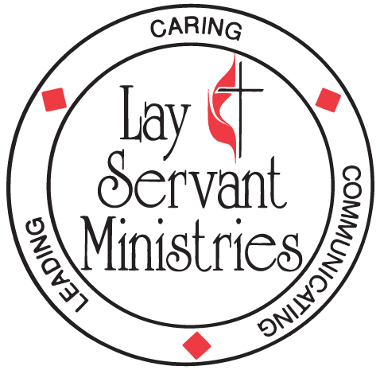

AFFIRMATION FORM
Please Print Legibly

Church Council or Charge Conference

By your signature you indicate this candidate has completed the Certified Lay Ministry (CLM) Coursework; Modules 1 through 4, the demonstration project and all requirements to become eligible for Certified Lay Ministry.

By your signature you indicate that SPRC has approved this candidate by majority vote.

By your signature you indicate this candidate has been affirmed at a regularly scheduled Church Council or Charge Conference of the local church as a candidate for Certified Lay Ministry.

Candidate Name: |  | Date:
Address:
City: | State: | Zip Code:
Phone (Day):
Phone (Evening or Cell):
Title/Position(s) in the UMC:
District:
Home Church:
Address:
City: | Sate: | Zip:
SPRC Chair Name: |  | Phone:
SPRC Chair Signature |  | Date:
Council Chair Name: |  | Phone:
Council Chair Signature |  | Date:
Pastor’s Name: |  | Phone:
Pastor’s Signature: |  | Date:

Completed form must be mailed to District Committee on Ordained Ministry

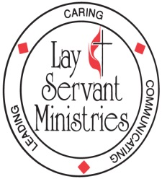

Certified Lay Ministry Process – Adopted Legislation at 2016 General Conference
(For more details please see Certified Lay Ministry Applicants Packet)

As part of a ministry team with supervision and support of a clergyperson:

- Conducts public worship
- Cares for the congregation
- Develops new faith communities
- Preaches the Word
- Leads small groups
- Establishes outreach ministries
- Serves as a class leader
- Engages in specialized ministries after appropriate training

REQUIREMENTS FOR CERTIFICATION:

- Certified as a lay servant, lay missioner
- Pastor and church council or charge conference recommendation
- Completion of a track of study as defined in ¶268 2016 Book of Discipline
- District Superintendent recommendation
- Appropriate screening & assessment
- Conference committee on Lay Servant Ministries approval after interview with and recommendation from district committee on Ordained Ministry

REQUIREMENTS FOR RENEWAL:

- Annual report
- Pastor and church council or charge conference recommendation
- Ministry review
- Lay Servant Ministries advanced course or approved continuing education event annually
- District Superintendent recommendation
- Conference committee on Lay Servant Ministries approval every two years after interview with and recommendation from district committee on Ordained Ministry

