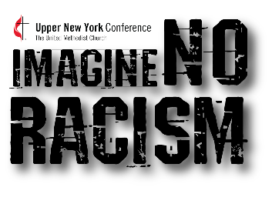
IMAGINE NO RACISM DISTRICT VOLUNTEER ADVOCATE
Upper New York Annual Conference
7481 Henry Clay Boulevard, Liverpool, NY 13088
Phone: (315) 898-2000
Web Site: www.unyumc.org
Email: ImagineNoRacism@unyumc.org

Name:________________________________________________________________________
Last First Middle

Are you clergy or laity? ◻ Clergy ◻ Laity District:_____________________________

Residential Address: ____________________________________________________________
Mailing Address: _______________________________________________________________
City: _____________________________ State: _____________________ Zip: _____________

Home Phone:______________________________ Cell Phone: __________________________

Email:______________________________________________

Passion for Racial Justice: Why are you applying to be an Imagine No Racism District Advocate? How do you feel called by Jesus Christ to share in the work of racial justice and equality in our annual conference and the world?

Experience with Racism, Racist Behavior & White Privilege: What training, education, work or volunteer experience have you had in regard to racism, racist behavior, and white privilege?

Continue on back

Walk of Faith: How are you involved in your local church? What spiritual practices do you regularly engage in? What acts of service do you engage in?

References: Please list three individuals who are not related to you by blood or marriage as
references. Please list people who have known you for at least three years.

Name:
Address:
Daytime Phone:
Evening phone:
Length of time you have known reference:
Relationship to reference:

Name:
Address:
Daytime Phone:
Evening phone:
Length of time you have known reference:
Relationship to reference:

Name:
Address:
Daytime Phone:
Evening phone:
Length of time you have known reference:
Relationship to reference:

Waiver and Consent:
I, _____________________________, hereby certify that the information I have provided on this application is true and correct. I authorize the Upper NY Conference to verify the information I have provided on this application by contacting the references and/or employers I have listed, by conducting appropriate background checks, or by other means, including contacting others whom I have not listed. I authorize the references and employers listed in this application to give whatever information they may have regarding my character and fitness for ministry on the Imagine No Racism District Team. I have read this waiver and the entire application, and I am fully aware of its contents. I sign this consent freely and under no duress or coercion.

____________________________________________________
Signature of Applicant Date

